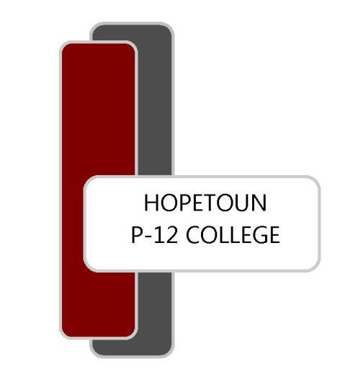

**HOPETOUN P-12 COLLEGE**

Dodgshun Street

PO BOX 211, Hopetoun VIC 3396

ABN 54302823924

Ph 03 5083 3203

Fax 03 5083 3016

Email [hopetoun.p12@education.vic.gov.au](mailto:hopetoun.p12@education.vic.gov.au)

***Meeting the individual needs of all students***

# *PARENT PAYMENT ARRANGEMENT*

Dear Parent/Guardian,

Hopetoun P-12 College is looking forward to another great year of teaching and learning and would like to advise you of the College’s voluntary financial contributions for 2024.

Schools provide students with free instruction to fulfil the standard Victorian curriculum. We want to assure you that all contributions are voluntary. Nevertheless, the ongoing support of our families ensures that our school can offer the best possible education and support for our students. We want to thank you for all your support, whether that’s through fundraising or volunteering your time. This has made a huge difference to our school and the programs we can offer.

Within our school this support has allowed us to offer a wide range of subjects and special curriculum activities for our students across all year levels, enhanced digital learning opportunities and the refurbishment of the school grounds.

For further information on the Department’s Parent Payments Policy please see a one-page overview attached.

Please complete, keep a copy, and return to school. **Any voluntary financial contributions are** **not due until 2024 school year commences.**

Yours sincerely,

*Helena Croser Simon Cook*

Principal School Council President

**parent PAYMENTS policy**

**ONE PAGE OVERVIEW**

|  |  |
| --- | --- |
|  | FREE INSTRUCTION   * Schools provide students with free instruction and ensure students have free access to all items, activities and services that are used by the school to fulfil the standard curriculum requirements in Victorian Curriculum F-10, VCE and VCAL. * Schools may invite parents to make a financial contribution to support the school. |

|  |  |  |  |  |
| --- | --- | --- | --- | --- |
|  | PARENT PAYMENT REQUESTS  Schools can request contributions from parents under three categories:   |  |  |  | | --- | --- | --- | | Curriculum Contributions  Voluntary financial contributions for curriculum items and activities which the school deems necessary for students to learn the Curriculum. | Other  Contributions  Voluntary financial contributions for non-curriculum items and activities that relate to the school’s functions and objectives. | Extra-Curricular Items and Activities  Items and activities that enhance or broaden the schooling experience of students and are above and beyond what the school provides for free to deliver the Curriculum. These are provided on a user-pays basis. |  * Schools may also invite parents to supply or purchase educational items to use and own (e.g. textbooks, stationery, digital devices). |

|  |  |
| --- | --- |
|  | FINANCIAL HELP FOR FAMILIES   * Schools put in place financial hardship arrangements to support families who cannot pay for items or activities so that their child doesn’t miss out. * Schools have a nominated parent payment contact person(s) that parents can have a confidential discussion with regarding financial hardship arrangements. |

|  |  |
| --- | --- |
|  | SCHOOL PROCESSES   * Schools must obtain school council approval for their parent payment arrangements and publish all requests and communications for each year level on their school website for transparency. |

Please **DO NOT** pay until 2024

Forms can be kept at home or forwarded to school for filing until the new school year

**HOPETOUN P-12 COLLEGE**

## **Parent Contributions Primary - Year 2024**

STUDENT NAME: ___________________________ YEAR LEVEL ______

**Contribution per family**

|  |  |
| --- | --- |
| **Curriculum Contributions** - items and activities that students use, or participate in, to access the Curriculum | Amount |
| General classroom consumables, materials and equipment  School Starter Pack and Additional Educational Items for use in the classroom includes: 2023 diaries and planners, reading diaries, reader bag, scrapbooks, dotted thirds paper, crayons, coloured and grey lead pencils, scissors, rubbers, textas, plastic pockets, document wallets, glue stick, whiteout tape, 14mm and 9mm lined books, Blu tack.  Printing and photocopying of worksheets and learning materials  Digital and Online Subscriptions for Learning – Mathletics,  Reading Eggs, Wushka licences and ACER testing.  Compass software for student and parent communication  Provision and upkeep of school devices from the shared classroom sets. | $100.00 |
| Swimming and Water Safety Program  Swimming Pool fees for Non-Members (of Hopetoun Swimming Pool) | $20.00 |
| Curriculum Activities  Student and transport costs to cover cultural performances and sporting activities held within the school and at Cluster schools. | $50.00 |
| **Total Curriculum Contributions** | **$** |
|  | |
| **Other Contributions -** for non-curriculum items and activities | **Amount** |
| School Grounds  Helps cover the cost of improving the College grounds. | $60.00 |
| Parents Club Membership  Membership of Hopetoun P-12 College’s Parents Club. | $2.00 |
| Parents Club Awards Night  Provides funds for the Parents Club to hold support events for Hopetoun P-12 College. | $15.00 |
| **Total Other Contributions** | **$** |
|  | |

**Extra-Curricular Items and Activities – provided on a user-pays basis**

Hopetoun P-12 College offers a range of items and activities that enhance or broaden the schooling experience of students and are above and beyond what the school provides in order to deliver the Curriculum. These are provided on a user-pays basis. These include safety glasses and school hats – all available from the general office.

The cost of extra-curricular items, activities and camps will be advised throughout the year.

|  |  |
| --- | --- |
| **Extra-Curricular Items and Activities** | **Amount** |
| School magazine | $20 |
| **Total Extra-Curricular Items and Activities** | **$** |

### Financial Support for Families

Hopetoun P-12 College understands that some families may experience financial difficulty and offers a range of support options, including:

* *The Camps, Sports and Excursions Fund for eligible Health Care Card holders*
* *State Schools Relief Fund (SSR)*
* *Payment plans for Extra-Curricular Items and Activities*

For a confidential discussion about accessing these services, or if you would like to discuss alternative payment arrangements, contact: *Ms Helena Croser, Principal* Ph: *03 5083 3203* | Email: *helena.croser@education.vic.gov.au*

**Totals**

|  |  |
| --- | --- |
| **Category** | Totals |
| Curriculum Contributions | $ |
| Other Contributions | $ |
| Extra-Curricular Items and Activities | $ |
| **Total** | **$** |

### Payment methods

**NB:** Payment via cheque, cash, direct deposit or BPAY please.

If paying via BPAY, ensure you have your family biller code and reference number.

Details for Direct Deposit are - Account Name: Hopetoun P-12 College School Council Official Account

Bank: CBA BSB: **063-692** Account Number: **1007 4788**

Please include your family name and description in the reference field when making payment.

**Signature - ………………………………………………… Date - …………………………**

### Refunds

Parent requests for refunds are subject to the discretion of the school and made on a case-by-case basis. Refunds will be provided where the school deems it is reasonable and fair to do so, taking into consideration whether a cost has been incurred, the Department’s Parent Payment Policy and Guidance, Financial Help for Families Policy and any other relevant information.